# 1. Site Map

# 2. MVC Project Structures

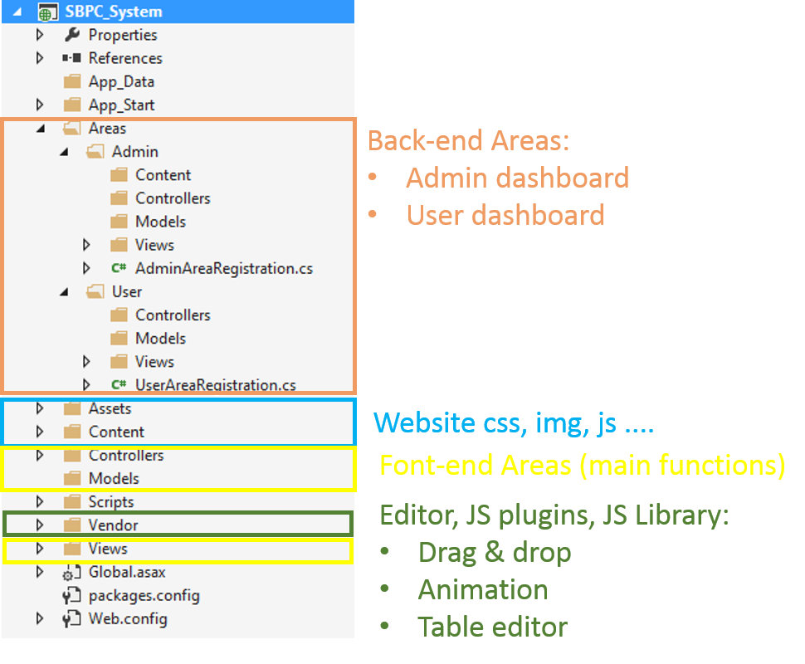

# 3. Notification

* Original UI template are committed via SVN, at caps-team7-fu/Design/Template Frame folder.
* All design must be created in MVC Project “SBPC System” at caps-team7-fu/SourceCode/SBPC Systems
* Main layout of UI is defined at Views/Shared/_Layout.cshtml, please reference if necessary.
* Each partial design are called “Complete” when suitable Controller return corresponding View.